6th Annual Gulfcoast Orthopaedic Rehabilitation Conference

Hyatt Regency, Sarasota, FL, August 17 2019


The Gulfcoast Orthopaedic Rehabilitation Conference is an event designed to bring orthopaedic surgeons, physical and occupational therapists together in an educational forum. Through a series of didactic lectures, leading area surgeons will discuss the treatment of various upper and lower extremity conditions and the role physical and occupational therapy plays in the management of these disorders. Multiple panel discussions allow for the therapists to interact with the surgeons in an effort to have open question and answer sessions between sets of lectures. The goal of this course to provide continuing education for physical and occupational therapists and Continuing Educational Units (CEU’s) can be claimed by those therapists attending this conference.

6th Annual Gulfcoast Orthopaedic Rehabilitation Conference
August 17th, 2019

Course Directors

Derek Cuff, M.D.
Suncoast Orthopaedic Surgery and Sports Medicine
Website: www.suncoastshoulder-elbow.com
Email: dcuff001@hotmail.com
Office: 941-485-1505

Assistant Director:
David Brown, DSC, MA, PT

Participating Faculty

Dan Lamar, M.D. Joe Noah, M.D.
Coastal Orthopaedics Suncoast Orthopaedic Surgery and Sports Medicine

Sean Dingle, M.D. Patrick O’Neil, M.D.
Kennedy-White Orthopaedic Center Kennedy-White Orthopaedic Center

Trevor Born, M.D Jeff Silverstein, M.D.
Sarasota Orthopaedic Associates Sarasota Orthopaedic Associates

Stephen Helgemo, M.D. Ed Stolarski, M.D.
Florida Hand Center Kennedy-White Orthopaedic Center

David Klein, M.D. David Chan, M.D.
Kennedy-White Orthopaedic Center Suncoast Orthopaedic Surgery and Sports Medicine

Paul Lento, M.D. Eric Sundberg, M.D.
Sarasota Orthopaedic Associates Coastal Orthopaedics

Arthur Valadie, M.D.
Coastal Orthopaedics

6th Annual Gulfcoast Orthopaedic Rehabilitation Conference
August 17th, 2019

Agenda

7:00–7:45 am – Breakfast: Bagels, Coffee, Assorted Teas
7:00-8:00 am - Course Registration and Sign In

8:00-8:05 am Introductions and Acknowledgment of Industry Supporters Derek Cuff, MD

SESSION I

8:05-8:20 Importance of the Surgeon-Therapist Relationship Derek Cuff, MD
8:20-8:35 Distal Radius Surgery: Where are we in 2019? David Chan, MD
8:35-8:50 Rehab for Arthritis in the Upper Extremity: Does it help? David Klein, MD
8:50-9:05 Advancements in Shoulder Replacement Derek Cuff, MD

9:05-9:30 Question and answer session regarding these topics

SESSION II

9:30-9:45 Dupuytren’s Contracture: Current Treatment Options Stephen Helgemo, MD
9:45-10:00 Evolution of Carpal Tunnel Surgery David Chan, MD
10:00-10:15 Role of Therapy in Non-op and Operative Shoulder Instability Derek Cuff, MD

10:15-10:40 Question and answer session regarding these topics

SHORT REFRESHMENT BREAK- 10:40-10:50

SESSION III

10:50-11:05 Ankle Fusion vs. Ankle Replacement: Pros and Cons Patrick O’Neil, MD
11:05-11:20 Disc Replacement vs. Fusion: Current Recommendations Eric Sundberg, MD
11:20-11:35 ACL Reconstruction: Where are we in 2019? Dan Lamar, MD
11:35-11:50 The Use of Regenerative Medicine in Orthopaedics Arthur Valadie, MD

11:50-12:10 Question and answer session regarding these topics

LUNCH BUFFET- 12:10-1:00

SESSION IV

1:00-1:15 The Role of PT in Outpatient Total Joint Replacement Ed Stolarski, MD
1:15-1:30 Robotic Surgery: Total Hip and Knee Applications Jeff Silverstein, MD
1:30-1:45 Surgical Approach for Total Hip: Does it Matter? Sean Dingle, MD

1:45-2:10 Question and answer session regarding these topics

Session V

2:15-2:30 Ultrasound: Role in Diagnosis and Rehab Paul Lento, MD
2:30-2:45 Achilles Tendon Tears: Nonsurgical and Surgical Options Joe Noah, MD
2:45-3:00 Hip Arthroscopy: Indications for Use Trevor Born, MD

3:00-3:20 Questions and answer session regarding these topics

FINAL REMARKS AND ADJOURN- 3:20-3:25

Industry Sponsors

Course organized by:



Thank you to our industry sponsors:


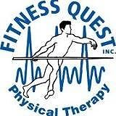



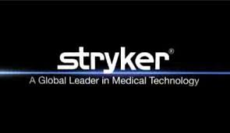

Surgery Center at St. Andrews 



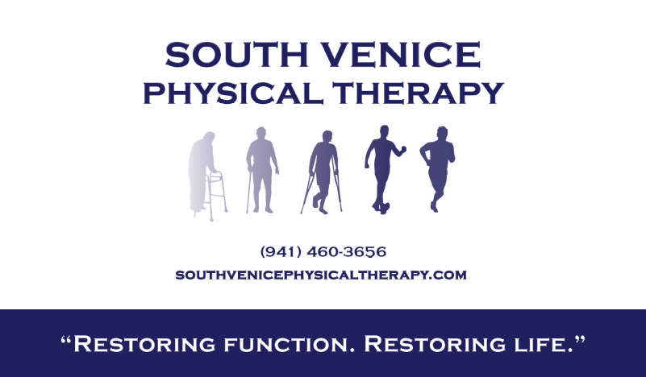



DISCLOSURE

To ensure balance, independence, objectivity and scientific rigor in all sponsored educational activities, all participating speakers, course directs and planning committee members are required to disclose to the program audience any financial relationships related to the subject matter of this program. Relationships of spouse/partner with proprietary entities producing health care goods or services should be disclosed is they are of a nature that may influence the objectivity of the individual able to control the content of the program. Specific disclosure information for each speaker, course director and planning committee member will be shared with the audience prior to the speaker’s presentation.

